**Master SpringBoot**

**07-Internationalization (i18n) implementation:**

**Step-00: Create new GIT branch for Internationalization**

* **git branch –vva**
* **git status ( make sure you are on master )**
* **git checkout –b 08-SpringBoot-Internationalization**
* **git push –set-upstream origin 08-SpringBoot-Internationalization**
* **git branch –a**

**git branch -vva**

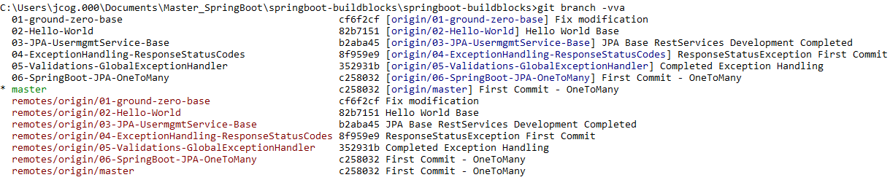

**git status**

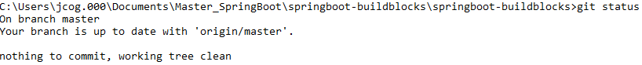

**git checkout –b 08-SpringBoot-Internationalization**



**git push –set-upstream origin 08-SpringBoot- Internationalization**

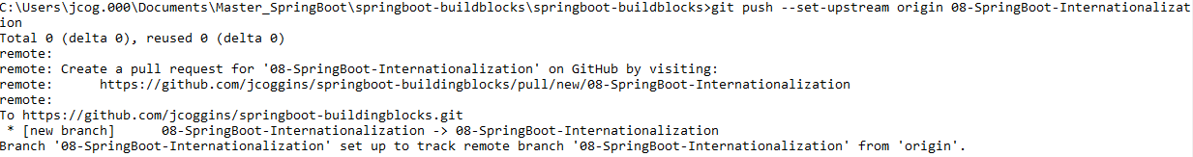

**git branch –a**

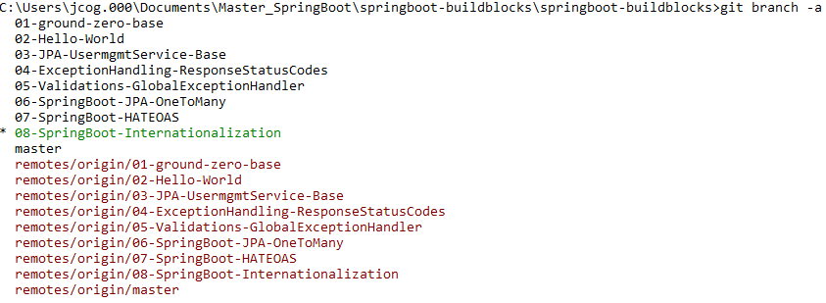

**Local branch and remote branch are the same**

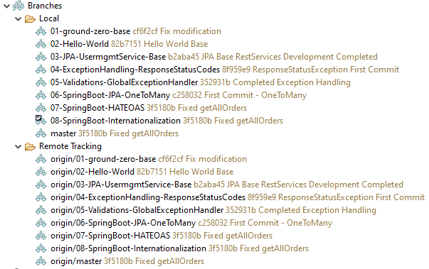

**Step-01: Create required beans**

* **Define a Bean named LocaleResolver**
* **Add messages.properties, messages_fr.properties**
* **Define a Bean named ResourceBundleMessageSource**

**Create the localeResolver BEAN**

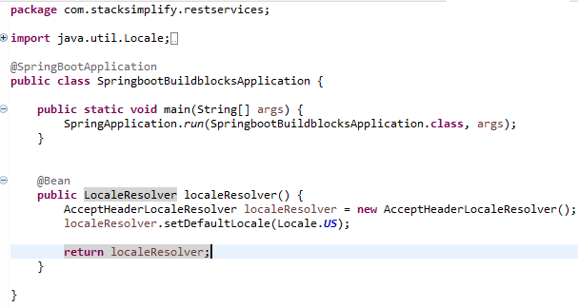

**Create the messages.properties file**

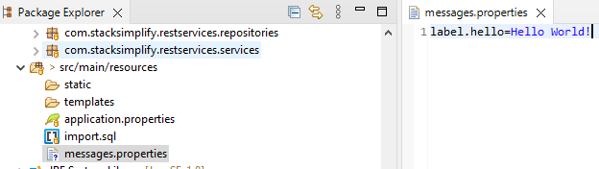

**Create the messages_fr.properties file**

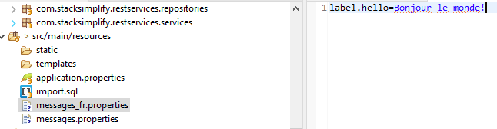

**Create the bean messageSource:**

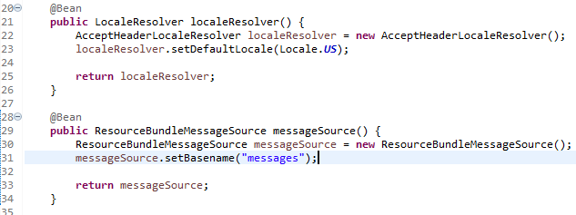

**Step-02: Create a REST service which supports i18n**

* **Create a helloi18n method in HelloWorldController**
* **Test it via Postman with “Accept-Language” headers**
  + **GET /hello-int**
  + **Accept-Language: fr**
  + **Accept-Language: us**
  + **Accept-Language: en**

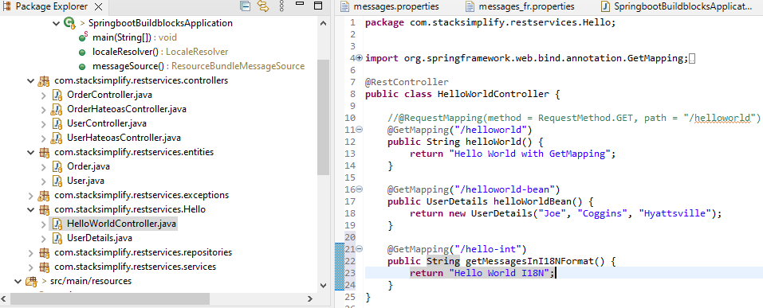

**Add @RequestHeader as a parameter:**

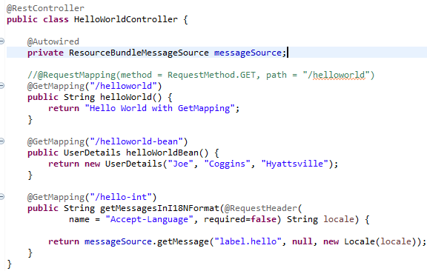

**Test with POSTMAN:**

**Test en**

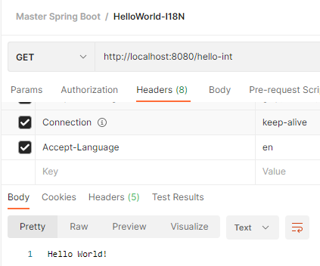

**Test fr**

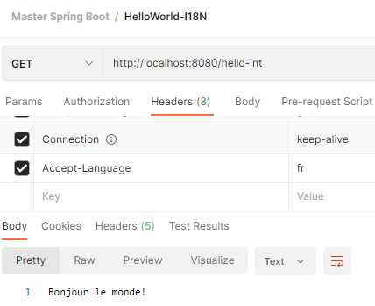

**Test us**

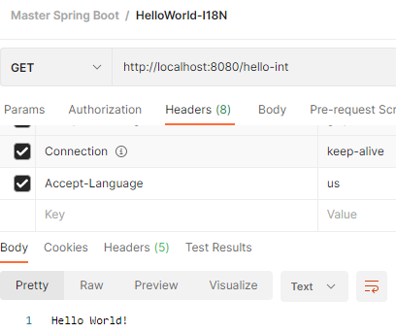

**git add . git commit –m “i18n – First Commit” git push**

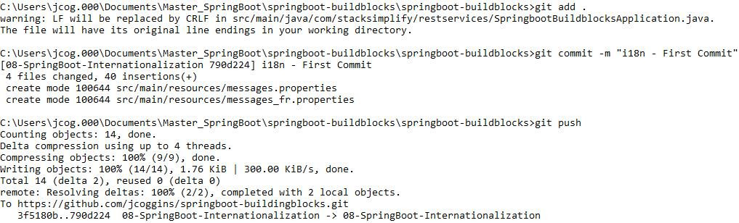

**git checkout master**



**git merge 08-SpringBoot-internationalization**

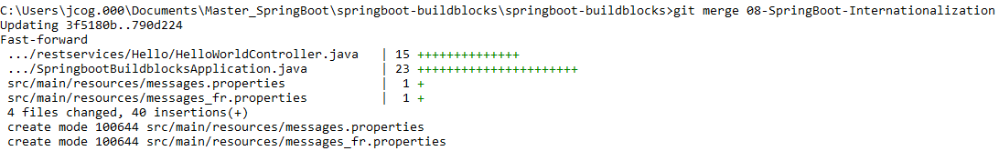

**git push git branch –vva**

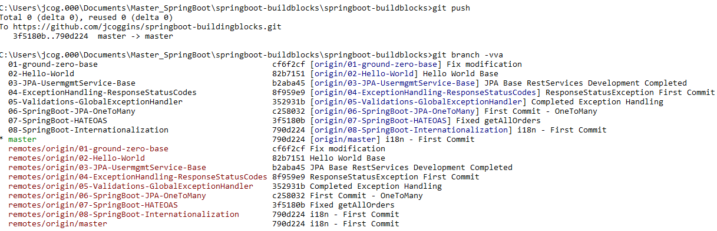

**Done!!**